RNASeq Workshop
November 5-7, 2020 Florida International University
November 12-14, 2020 University of Puerto Rico
November 19-21, 2020 University of Puerto Rico

Steps to login to FIU nodes that run Linux OS [for Windows users]
Step 1: Change password
Before you proceed you need to change the password you were given by FIU.
At: https://support.cis.fiu.edu/pw-change/changepw.php
Ignore error message
When you do this it might list “ Error changing AD password” , however it also says “Your AUL UNIX Password changed Successfully”. This is correct as you now have partial access to the server at FIU

Step 2: Install MobaXterm
MobaXterm is an all-in one program for Windows that integrates a terminal program, an X server, an SSH client and a graphical SFTP client into one package with an easy-to-use interface.
- Download the Home Edition of MobaXterm (https://mobaxterm.mobatek.net/download-home-edition.html). Make sure to select the Installer edition rather than the Portable edition.
- Click on the downloaded zip file to open it, and then click on the MobaXterm installer msi file to begin the installation.
- Once the install has finished, open the MobaXterm app. In the main window, you will see a list of saved sessions in the left-hand column. If you have previously installed and used PuTTY, any saved PuTTY sessions will also be listed.
(Taken from http://latisresearch.umn.edu/installing-mobaxterm-windows)

Step 3: Login to wolf server (wolf.cs.fiu.edu)
- Open MobaXterm app and click on “session” icon on the menu bar.
- Click “SSH” on the “Session settings” window.
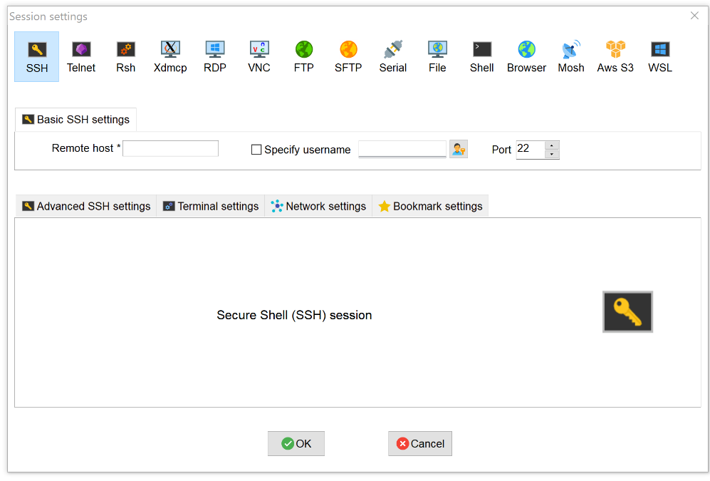

- Enter wolf.cs.fiu.edu as “Remote host”
- Check the box next to “Specify username”
- Enter username in the text box next to “Specify username”
- Click OK
- It will now show Password:
Type your password. It will look like it is not typing but it is storing the information
It will then show the following text:
Welcome to the new wolf.cs.fiu.edu, now running CentOS 7!
YourUserName@wolf:~ 1%
[In the above line it will show your given username not words YourUserName. The number before % can vary]
If you see the above two lines highlighted in bold your login to wolf server is successful. You can ignore any other messages.

Step 4: Login to one of the worker nodes (bioinfo-01.cs.fiu.edu or bioinfo-08.cs.fiu.edu)
Participants were given access to 8 worker nodes. To login to one of the 8 nodes type ssh and the address of the node after the % symbol. [You can highlight text and paste it by pressing the mouse button on the right.]
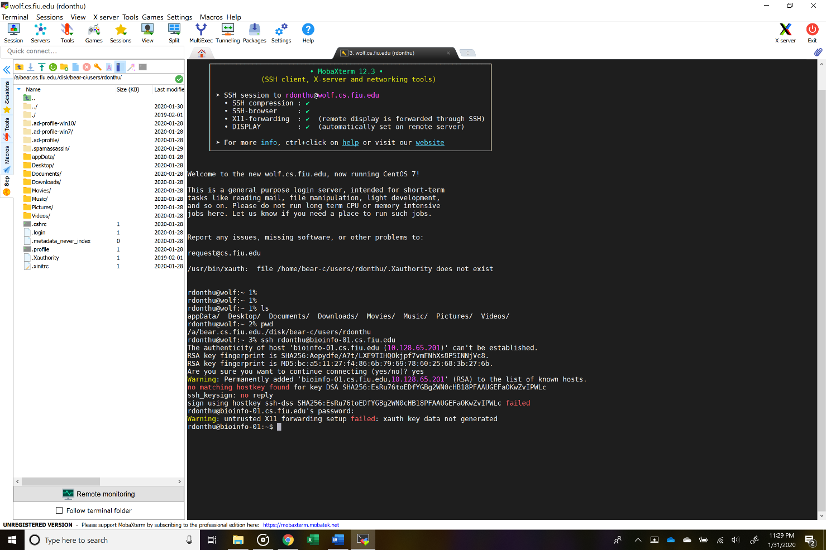
- It will show “The authenticity of host 'bioinfo-01.cs.fiu.edu (10.128.65.201)' can't be established”
“ RSA key fingerprint is SHA256……..”
“Are you sure you want to continue connecting (yes/no)?”
- Type Yes.
- It will show “Warning: Permanently added 'bioinfo-01.cs.fiu.edu,10.128.65.201' (RSA) to the list of known hosts”
- username@bioinfo-01.cs.fiu.edu's password:
- Type your password and click enter.
- It will show your username@bioinfo-01: ~$

If you see the message highlighted in blue that means you are logged into the worker node. All the Linux commands mentioned in the review and practice material need to be entered on the worker nodes.

Future logins to worker nodes:

To login again to worker nodes first login to wolf server using Step 3 and then login to worker node using Step 4.

Steps to login to FIU nodes that run Linux OS [for Mac users]
Step 1: Change password
Before you proceed you need to change the password you were given by FIU. At: https://support.cis.fiu.edu/pw-change/changepw.php
Ignore error message
When you do this it might list “ Error changing AD password” , however it also says “Your AUL UNIX Password changed Successfully”. This is correct as you now have partial access to the server at FIU

Step 2: Open a terminal window
The following youtube video shows how to open a terminal window on a Mac
https://www.youtube.com/watch?v=zw7Nd67_aFw

Step 3: Login to wolf server (wolf.cs.fiu.edu)
- Type ssh username@wolf.cs.fiu.edu [replace the word username with your actual username]
- It will now show Password:
Type your password. It will look like it is not typing but it is storing the information
It will then show the following text:
Welcome to the new wolf.cs.fiu.edu, now running CentOS 7!
YourUserName@wolf:~ 1%
[In the above line it will show your given username not words YourUserName. The number before % can vary]
If you see the above two lines highlighted in bold your login to wolf server is successful. You can ignore any other messages.

Step 4: Login to one of the worker nodes (bioinfo-01.cs.fiu.edu to bioinfo-08.cs.fiu.edu)
Participants were given access to 8 worker nodes. To login to one of the 8 nodes type ssh and the address of the node after the % symbol. [You cannot copy paste. You have to type it.]
- It will show “The authenticity of host 'bioinfo-01.cs.fiu.edu (10.128.65.201)' can't be established”
“ RSA key fingerprint is SHA256……..”
“Are you sure you want to continue connecting (yes/no)?”
- Type Yes

- It will show “Warning: Permanently added 'bioinfo-01.cs.fiu.edu,10.128.65.201' (RSA) to the list of known hosts”.
- username@bioinfo-01.cs.fiu.edu's password:
- Type your password and click enter.
- It will show your username@bioinfo-01: ~$

If you see the message highlighted in blue that means you are logged into the worker node. All the Linux commands mentioned in the review and practice material need to be entered on the worker nodes.

Future logins to worker nodes:

To login again to worker nodes first login to wolf server using Step 3 and then login to worker node using Step 4.

